Cost of small-scale TOS production…

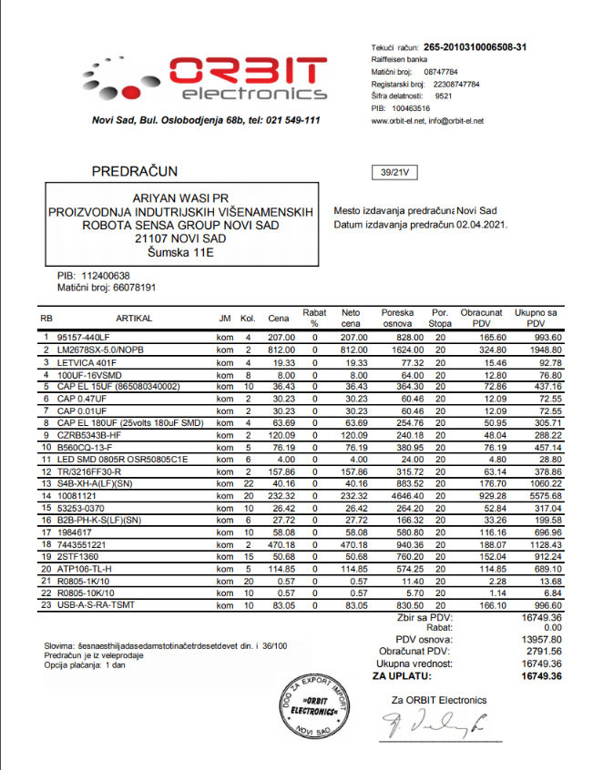The given numbers are for one unit.

**Electronic components: 70€**

(The picture to the right -> is the offer

from a local supplier. This offer is given in

Serbian dinars and for two units. So, I halved

the asking price and converted into euros.)

**Raspberry pi: 52€**

(can maybe get away with a rpi zero?)

<https://www.malina314.com/proizvod/raspberry-pi-4-2gb-ram/>

**Mechanical components: 50€**

(thought of a better way to the case, it’s going

to be partly build with 3D printed parts and

the main box will be a project box. This is

basically it:

<http://www.proelectronic.rs/Kutije/Plasti%C4%8Dne/12590-PLASTICNA%20KUTIJA%20KP-30> but it will of course look better when all the things are mounted. Plus, its not glossy… which I didn’t like with the last design. So, we would in essence have different 3D-printed mounting brackets inside for all of the things.)

**Power supply: 70€**

http://www.sahel.rs/sa-0100-720.html?___SID=U

**PCB Manufacturing: 10.8€**

(It actually costs 54€however, thats 5 pieces. Can only order 5 pieces at a time. This is one area we can lower the costs to if you want, to 7€ per board. The additional cost is 2oz of copper instead of 1oz.)

------------------------------------------------------------------------------------------

**Cost per board: 252,8**€ (we need to get 5 boards, so actually: **296€**)

**Labor per unit: 150€**

**Total for two units to be built: 838**€